TextVenturer

Version 1.0

Revision History

|  |  |  |  |
| --- | --- | --- | --- |
| **Date** | **Version** | **Description** | **Author** |
| 01/11/16> | <0.1> | <UC-Enter Room> | <Simon Vollmer, Dominik Vogel, André Schmitt> |
|  |  |  |  |
|  |  |  |  |
|  |  |  |  |

Table of Contents

1. Use-Case Name 3

1.1 Brief Description 3

2. Flow of Events 3

2.1 Basic Flow 3

2.2 Alternative Flows 3

2.2.1 < First Alternative Flow > 3

2.2.2 < Second Alternative Flow > 3

3. Special Requirements 3

3.1 < First Special Requirement > 3

4. Preconditions 3

4.1 < Precondition One > 3

5. Postconditions 3

5.1 < Postcondition One > 3

6. Extension Points 3

6.1 <Name of Extension Point> 3

# Use-Case Name

## Brief Description

In the following UC-Diagram u can see what happens if you enter a new room.C:\Users\SimonVollmer\AppData\Local\Microsoft\Windows\INetCacheContent.Word\Raum.png

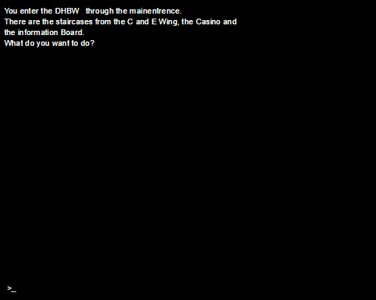

# Flow of Events

## Basic Flow

The purpose of the “Room Enter” UC is to get every information whenever you enter a new room.

## Alternative Flows

n/a

# Special Requirements

n/a

# Preconditions

n/a

## < Precondition One >

# Postconditions

n/a

# Extension Points

n/a